Rapa Nui Mata'a Morphometric Analyses

Carl P. Lipo, Rene Horneman, Terry L. Hunt, Vincent Bonhomme

7 September 2014

# Introduction

Rapa Nui (Easter Island, Chile) is a tiny island located in a remote corner of Eastern Polynesia, more than 2000 km from the nearest inhabited body of land (Figure 1). The island was first colonized by Polynesians who sailed from central East Polynesia in voyaging canoes during the 13th century AD (Hunt & Lipo 2006; Wilmshurst *et al.* 2011). Depsite the island's diminuitive size, remoteness, and limited natural resources, the archaeological record of Rapa Nui is well-known for its nearly 1000 multi-ton statues known as *moai* that once sat atop massive stone platforms known as *ahu* (Hunt & Lipo 2011a).



Figure 1. Location of Rapa Nui in Polynesia.

The dramatic prehistoric investment in monumental architecture stand in marked contrast to the Rapa Nui's environment and historically observed population levels. Even at the first point of European contact, the tiny island was largely devoid of trees and population sizes were just about 3000 individuals (Hunt & Lipo 2011a). While earlier researchers (e.g., Heyerdahl & Ferdon 1965; Heyerdahl 1989) believed the depleted and depauperate state of the island was due to conflict between Polynesians and elite from South America, more recent reseachers have interepreted the contrast between the spectacular nature of the archaeological record and the sparse enviornment of the island as the outcome of a prehistoric environmental catastrophe (Bahn & Flenley 1992; Flenley & Bahn 2003). These researchers argue that based largely on oral traditions, that prehistoric populations grew in numbers until resource use exceeded the carrying capacity and the island underwent catastropic demographic collapse. This account has been popularlized as the "collapse" scenario (*sensu* Diamond 1995, 2005).

New research, however, has challenged this notion with empirical evidence generated from the archaeological record that the Rapanui flourished on the island until AD 1722 when Europeans brought diseases and other social disruptions (Hunt 2007; Hunt & Lipo 2007; Hunt & Lipo 2009a; Hunt & Lipo 2009b; Hunt & Lipo 2011a; Hunt & Lipo 2011b; Lipo & Hunt 2009; Mulrooney *et al.* 2009; Mulrooney 2012; Rainbird 2002). Investigations on Rapa Nui's settelement patterns demonstrates that the island's inhabitants lived in a dispersed pattern in a low density fashion (Hunt & Lipo 2011a; Morrison 2012). In addition, studies show that subsistence was largely based on extensive but marginally productive lithic mulch gardens to boost the nutrient-poor soil to a level that sustained sweet potato cultivation (Bork *et al.* 2004; Ladefoged *et al.* 2005; Ladefoged *et al.* 2010; Ladefoged *et al.* 2013; Mieth *et al.* 2006; Stevenson & Haoa 2002; Stevenson *et al.* 2006). Finally, demise of the once extensive palm tree forest appears to have had little to do with statue construction or changes in carry capacity (Hunt & Lipo 2011a; Lipo *et al.* 2013).

One of the claims that persists that is thought to support the "collapse" scenario is the idea that prehistoric Rapa Nui populations experienced intense warfare during late prehistory when resources became increasingly scarce (Bahn & Flenley 1992; Diamond 1995, Diamond (2005); Flenley & Bahn 2003). Oral traditions are known that attribute the toppling of stone statues to intertribal prehistorc warfare (Bahn & Flenley 1992). But the existence of fallen statues alone does not necessarily imply warfare since other natural explanations are more likely (Edwards *et al.* 1996). Indeed, the existing evidence points to the toppling of statues as as series of post-contact historic events rather than prehistory (Hunt & Lipo 2011a). Most significantly, examples of defensive structures are entirely lacking in the island's archaeological record (Hunt & Lipo 2011a; Lipo & Hunt 2014). Overall, much of the evidence for prehistoric warfare among the inhabitants of Rapa Nui comes from oral traditions recorded in the 20th century (e.g., Routledge 1919). The oral traditions, however, have an unknown relation to prehistory. Metraux (1940), for example, argues that most of the traditions are likely recent and thus likely do not reflect prehistoric events. Given the unknown origins of oral traditions, we must rely upon direct archaeological evidence for warfare.

The one example of empirical evidence used to support arguments about prehistoric warfare on Rapa Nui is the presence of *mata’a*, flaked obsidian stemmed tools. *Mata’a* are a class of hafted flaked obsidian artifacts that are found commonly on Rapa Nui. As relatively simple stemmed obsidian tools with wide blades, their form is similar to artifacts known as *mata* found on other Polynesian islands such the basalt artifacts found on New Zealand, Pitcairn and the Chatham Islands (Balfour 1917; Metraux 1957: 232; Skinner 1958) as well as New Britain, Papua New Guinea (e.g., Araho 1997; Specht *et al.* 1988; Torrence, Swadling, & Ambrose*et al.* 2009; Torrence, Swadling, & Kononenko*et al.* 2009; Torrence *et al.* 2013).

<< probably should put a photo of mataa here .. >>

In the current analysis, we seek to explore whether there exists variability in the shape of *mata'a* that sheds provides information about the fucntional environment in which these artifacts interacted. Using a large image database of 'r numberOfMataa' *mata'a* from Rapa Nu, we conduct quantitative morphometric analyses to further investigate whether specific tool classes might be identifiable in the range of shapes in which these artifacts are found. Morphometric analyses enable on to explore shape as a continuous property of objects rather than requiring us treat shape as nominal categories. In this way we can use principal components analyses to see of particular kinds of shapes map to particular locations, environments or source material. In addition, we can examine the relative patterns *mata’a* shape variability and to look for areas of shape that are constrained versus those that were more free to vary. Overall, our results conclude that mata’a were only functionally constrained in terms of the haft and had signficant variation on the distal end and blade. These results continue to support the alternative hypotheses that these artifacts were not used as weapons. The degree of similarity, however, of the haft portion of *mata'a* and the low degree of constraint in the blade poses an intriguing puzzle: we have yet to identify the role(s) that these objects played in Rapa Nui subsistence and settlement.

# Approach

*Mata'a* have been noted since the earliest European visitors described the island. Members of Cook's expedition to the island commented that the islanders “had lances or spears made of thin ill-shaped sticks, and pointed with a sharp triangular piece of black glassy lava” (Saher 1990: 35). *Mata'a* are often assumed to be "spears" largely because of their resemblance to European varieties rather than any direct observation of their use. Scars noted by early European observers are also believed to have been inflicted by *mata'a* though there is no clear evidence that their use was lethal. For example, in his voyage to Rapa Nui in 1770, Captain Don Felipe González (Haedo & Roggeveen 1908: (13):99) remarked that "they [Rapanui] possess no arms, and although in some we observed sundry wounds on the body, which we thought to have been inflicted by cutting instruments of iron or steel, we found that they proceeded from stones, which are their only [weapons of] defence and offence, and as most of these are sharp edged they produce the injury referred to."

Even if we had direct observations of these objects being used in "spear-like" fashion, the unavoidable tendency for these European observers to interpret what they saw through their own preconceptions requires us examine the physical evidence available on mata'a. In this way we can learn not only the range of interactions that the objects had with the environment but also determine if there is variablity in their use through time or over space.

On the surface landscape of Rapa Nui, *mata'a* are one of the most numerous shaped artifact classes. Overall, *mata'a* vary greatly in size and shape, but average 6-10 cm in width and length. Technologically, they are formed from unifacial flakes derived trough hard hammer percussion on obsidian cores quarried from one of the island's obsidian sources. Most of the shaping of the *mata'a* occurs during the creation of a stem that presumably serves as a haft. The stem is formed from one of the lateral margins of the original flake where blade constitutes the remaining distal and opposite lateral margins. *Mata'a* stems and shoulders are formed by unifacial flaking and are generally lenticular in cross section. Overall, the blade shape is dominated by the shape of the parent flake though some shaping through secondary flaking is sometimes evident. Often, large areas of cortex still cover much of one face.

In exploring the the way in which *mata'a* forms vary, researchers have noted that there is a great diversity of shapes that vary from rounded to subangluar to angular to complex (Mulloy 1961). Early researchers assigned mata`a shape variation to what they conceived as ethnographic categories based on Rapanui words (i.e., Routledge 1919). Later attempts to construct systematic classifications have also focused on identifying types based on characterizations of overall shape. None of these classification efforts produced useful categories.

Mulloy (1961: 151), for example, argued that “no significant clustering or correlations could be extracted.... the material represents a continuous range of variation without objective natural order, and that the only classification possible must involve the subjective selection of ideal types from infinite series of possibilities, and the arbitrary reference of intermediate for to one or another of these.” Mulloy concluded manufacturing procedures dictated shapes and differences in overall shape of mata’a were best explained by chance.

The overall shape of an object is rarely a useful dimension for problem-oriented classification (Dunnell 1986). The forms of objects are limited by technological constraints of the material, performance aspects that depend upon the range of environments in which the object is used, and simple idiosyncratic variability related to the manufacturer and the process of production. In the case of *mata’a* much of the variability in the overall blade shape can be explained by the contingent results involved in the stages of manufacture (Bollt *et al.* 2006). The difference in shapes, therefore, may have structured functional variation related to the range and kinds of activities for which the tool was primarily used. Studies of use-wear found on *mata'a* point to the tool being used primarily for scraping and cutting or some combination (Church & Rigney 1994; Church & Ellis 1996).

A recent study of *mata'a* shape using stylistic classes and deterministic frequency seriation as a means for examining how class frequencies changed over space and through time showed remarkably continuous change (Lipo *et al.* 2010). The seriation results suggest that the source of variability in *mata'a* form is largely being inherited through the social learning of manufacturing techniques between indivdiuals. The evidence also indicates that variability in the form of *mata'a* is not related to how the *mata'a* performed in its use environment(s). Overall, our growing understanding of *mata'a* variability continues to support their form being related to ceremonial or cultivation activities and not as weapons invovled in warfare (Bollt *et al.* 2006; Lipo *et al.* 2010).

In our analysis here, we focus on *mata'a* variability in the blade portion of the mata'a relative to the stem. We assume that as hafted objects the point at the center of the stem where it meets the blade can be held constant for comparisons of shape. We then assume that due to performance the functional aspects of the tool will result in shape variability that is more constrained than the non-functional or stylistic attributes (Lipo *et al.* 2012). The constraints are the result of natural selection that serves to sort shape variability in proportion to the benefits/drawbacks to performance. Based on this notion, we hypothesise that:

* If *mata’a* are weapons, the distal end of the artifact will be constrained. However, if *mata’a* are not weapons, other areas of the tool will show greater constraint consistent with alternate functions.
* If *mata’a* are weapons, the distal end of the artifact will show a tendency towards a pointed spear-like shape that will penetrate either enemies or prey. If *mata’a* are not weapons, there will be no such constrictive tendency at the distal end of the tool.
* If there was inter-tribal warfare, *mata’a* from distinct areas may show stylistic traits of distinct groups. If natives were not divided into warring groups, distinct stylistic traits may or may not be apparent.

# Methods and Data

In order to test these hypotheses, we used morphometric outline analysis. Morphometrics is the quantitative analysis of form in terms of shape and size (Bookstein 1982; Bookstein *et al.* 1985; Bookstein 1997; Cardillo 2010; Kendall 1989; Rohlf 1990). It has advantages over traditional studies of shape that treat shape as a nominal character (e.g., "triangular", "square", "round"). Even classifications that break shape into a series of dimensionally constructed classes reduce variability into modal categories. Morphometrics avoid the problem of nominal shape by analyzing the form of objects as a series of metric measurements that characterize the relative positions of series of landmarks or comprise the outline. Analysies of form variability can be conducted in two and three dimensions (Kendall 1989). With techniques available for standardizing scale and rotation, morphometric measurements directly compare outlines of artifacts and generate data on the variations between artifacts. Consequently, one major feature of morphometrics is its ready ability to statistically test hypotheses about the factors that affect shape.

Measurements for morphometrics can be generated in a number of ways. With roots in biology, the earliest form of morphometrics focused on identifying the location specific landmarks (e.g., Thompson 1917). A landmark approach requires defining features of interest that are to be examined as to how they relate to each other. In the case of artifacts such as *mata'a* there are few consistent landmarks to hold constant other than perhaps the distal and proximal end. One can also one can conduct an analysis of what is known as "semi-landmarks," a fixed number of regularly positioned points around the outline of an object (Bookstein 1997; Gunz & Mitteroecker 2013). Both approaches to measuring shape make use of the relative positions between all points (Bookstein 1991; 1997).

In our morphometric analyses we make use of Momocs (<http://CRAN.R-project.org/package=Momocs>), an R package (R Core Team 2014) developed by Bonhomme (2012; Bonhomme *et al.* 2014). Momocs builds upon techniques developed by Claude (2008) and reviewed by Bowman (2009). Bonhomme incorporated functions from Claude's work into an integrated framework and a standalone R package. The package's vignette *A Graphical Introduction to Momocs and Outline Analysis Using R* (Bonhomme 2012) provides an extensive description of the functions of the package.

Table 1: *Mata'a* included in analyses by collection location.

|  |  |  |  |  |  |
| --- | --- | --- | --- | --- | --- |
|  | Ahu Tautira | Orito | Orongo | Rano Kau | Unknown |
| Bishop | 0 | 0 | 0 | 0 | 291 |
| Englert | 25 | 31 | 29 | 33 | 0 |

Table 2: *Mata'a* included in analyses by obsidian source.

|  |  |  |  |  |  |
| --- | --- | --- | --- | --- | --- |
|  | Ahu Tautira | Orito | Orongo | Rano Kau | Unknown |
| Motu Iti | 0 | 0 | 0 | 0 | 5 |
| Orito | 0 | 0 | 0 | 0 | 279 |
| Rano Kau 1 | 0 | 0 | 0 | 0 | 7 |
| Unknown | 25 | 31 | 29 | 33 | 8 |

For our analyses of Rapa Nui *mata'a*, our assemblage consisted of planview photographs of (N=417) artifacts from two museum collections. Outlines of the studied *mata'a* are shown in Figure 3). The first museum collection consisted of 118 *mata'a* housed at the P. Sebastian Englert Museum on Rapa Nui. This collection is composed of photograps of *mata'a* collected from 0 locations on the island as well as 0 *mata'a* for which provience is known only to the level of the island itself (Figure 2).

The second collection of *mata'a* is composed of 291 objects housed at the Bishop Museum, Honolulu, Hawai'i. These *mata'a* consist of examples purchased from the island by a private collector in 1920, collections made by Kenneth P. Emory in 1929-1931 and various gifts to the museum (Mulrooney *et al.* 2014: 5–6). Mulrooney and colleagues took photos of these *mata'a* during their study of obsidian sourcing via pXRF (Mulrooney *et al.* 2014). Their findings demonstrate that the majority of *mata'a* were made from obsidian obtained at the Orito source, though some examples are made from obsidian from the Rano Kao and offshore Motu Iti sources. Due to the manner in which the Bishop Museum material was originally collected, we can only attribute the source of these *mata'a* to Rapa Nui and and not a specific location on the island. Mulrooney and colleagues, however, kindly provided source identifications for each *mata'a* based on the results of their study. In this way, we are able to use these *mata'a* examples to examine potential shape variability that might be due to the obsidian source. This shape variability could be potentially caused by systematic material differences or by the differential use of *mata'a* that are dervied from different locations.



Figure 2. Locations of *mata'a* collections from Rapa Nui, Chile.

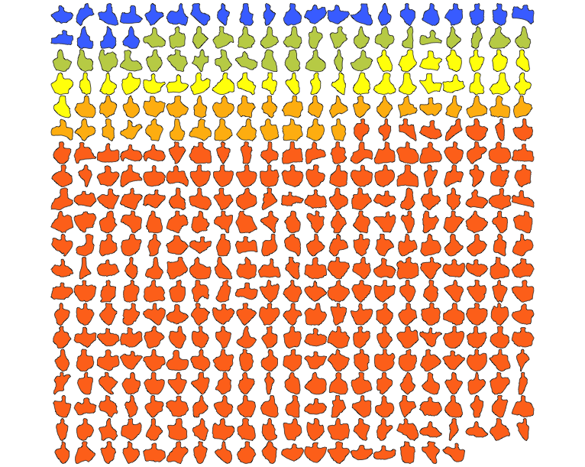

Figure 3. *Mata'a* included in the current analyses. The 5 colors indicate the collection locations on Rapa Nui (Blue=Ahu Tautiri, Green=Orito, Yellow=Orongo, Orange=Rano Kao, Red=Location only known to the level of the island).

For the purposes of our analyses and following the approach taken in Lipo *et al.* (2010), we assumed that *mata'a* are the hafted portions of compound tools that are otherwise incompletely preserved in archaeological deposits. In this context and based on evidence of usewear on the distal edges (Church & Rigney 1994; Church & Ellis 1996), we assume that the overall shape of *mata'a* shape is a functional element (sensu Dunnell 1978), the portion of the artifact that interacts with the environment. Consequently, our interest is on those aspects of shape that potentially affect function and thereby come under natural selection. The task of explaining variability in shape consists of identifying selective pressures that affect the performance of shape and to determine whether their magnitude is sufficiently great to impact fitness. The greater the selective pressures on performance, the more constraint we would expect on those aspects of shape. If the effect on function and performance is sufficiently small, then other forces such as technological (i.e., material source, manufacturing steps, etc.) or stylistic (stochastic or neutral) ones may have played a role in fixing the shapes of *mata'a*, as well as when and where they occur in the archaeological record. In these cases, we would expect to see a greater range of variability. It is possible, however, that not all *mata'a* instances were used in the same way. If *mata'a* shapes is influcenced by more than one function, either contemporaneously or over time, then the selective context will differ and thus the “cause” of *mata'a* shape should vary. This situation should create modal patterns of mata'a where shape variability forms statistically distinguishablke groups.

# Data

In our analyses, we aligned scaled photos of *mata'a* at the point where the midpoint of the stem meets the blade. We oriented each image with the centerline of the haft. These steps helped insure that the shapes were directly comparable. We converted the images to binary to isolate the artifact from the background and then used TPSdig software (Rohlf 2014) to create outlines of each *mata’a*. TPSDig was particularly useful as it provides a means for automatically tracing outlines with a fixed number of points. In the creation of outlines, we identified 200 sets of X-Y coordinates located on equidistant points along the perimeter of the artifact (Figure 4). The set of coordinates for each mata'a were aggregated into a single file using PAST (Hammer *et al.* 2001). Finally, we standardized the outlines for differences in sizes by dividing the cooridinate positions by the total length of each outline.

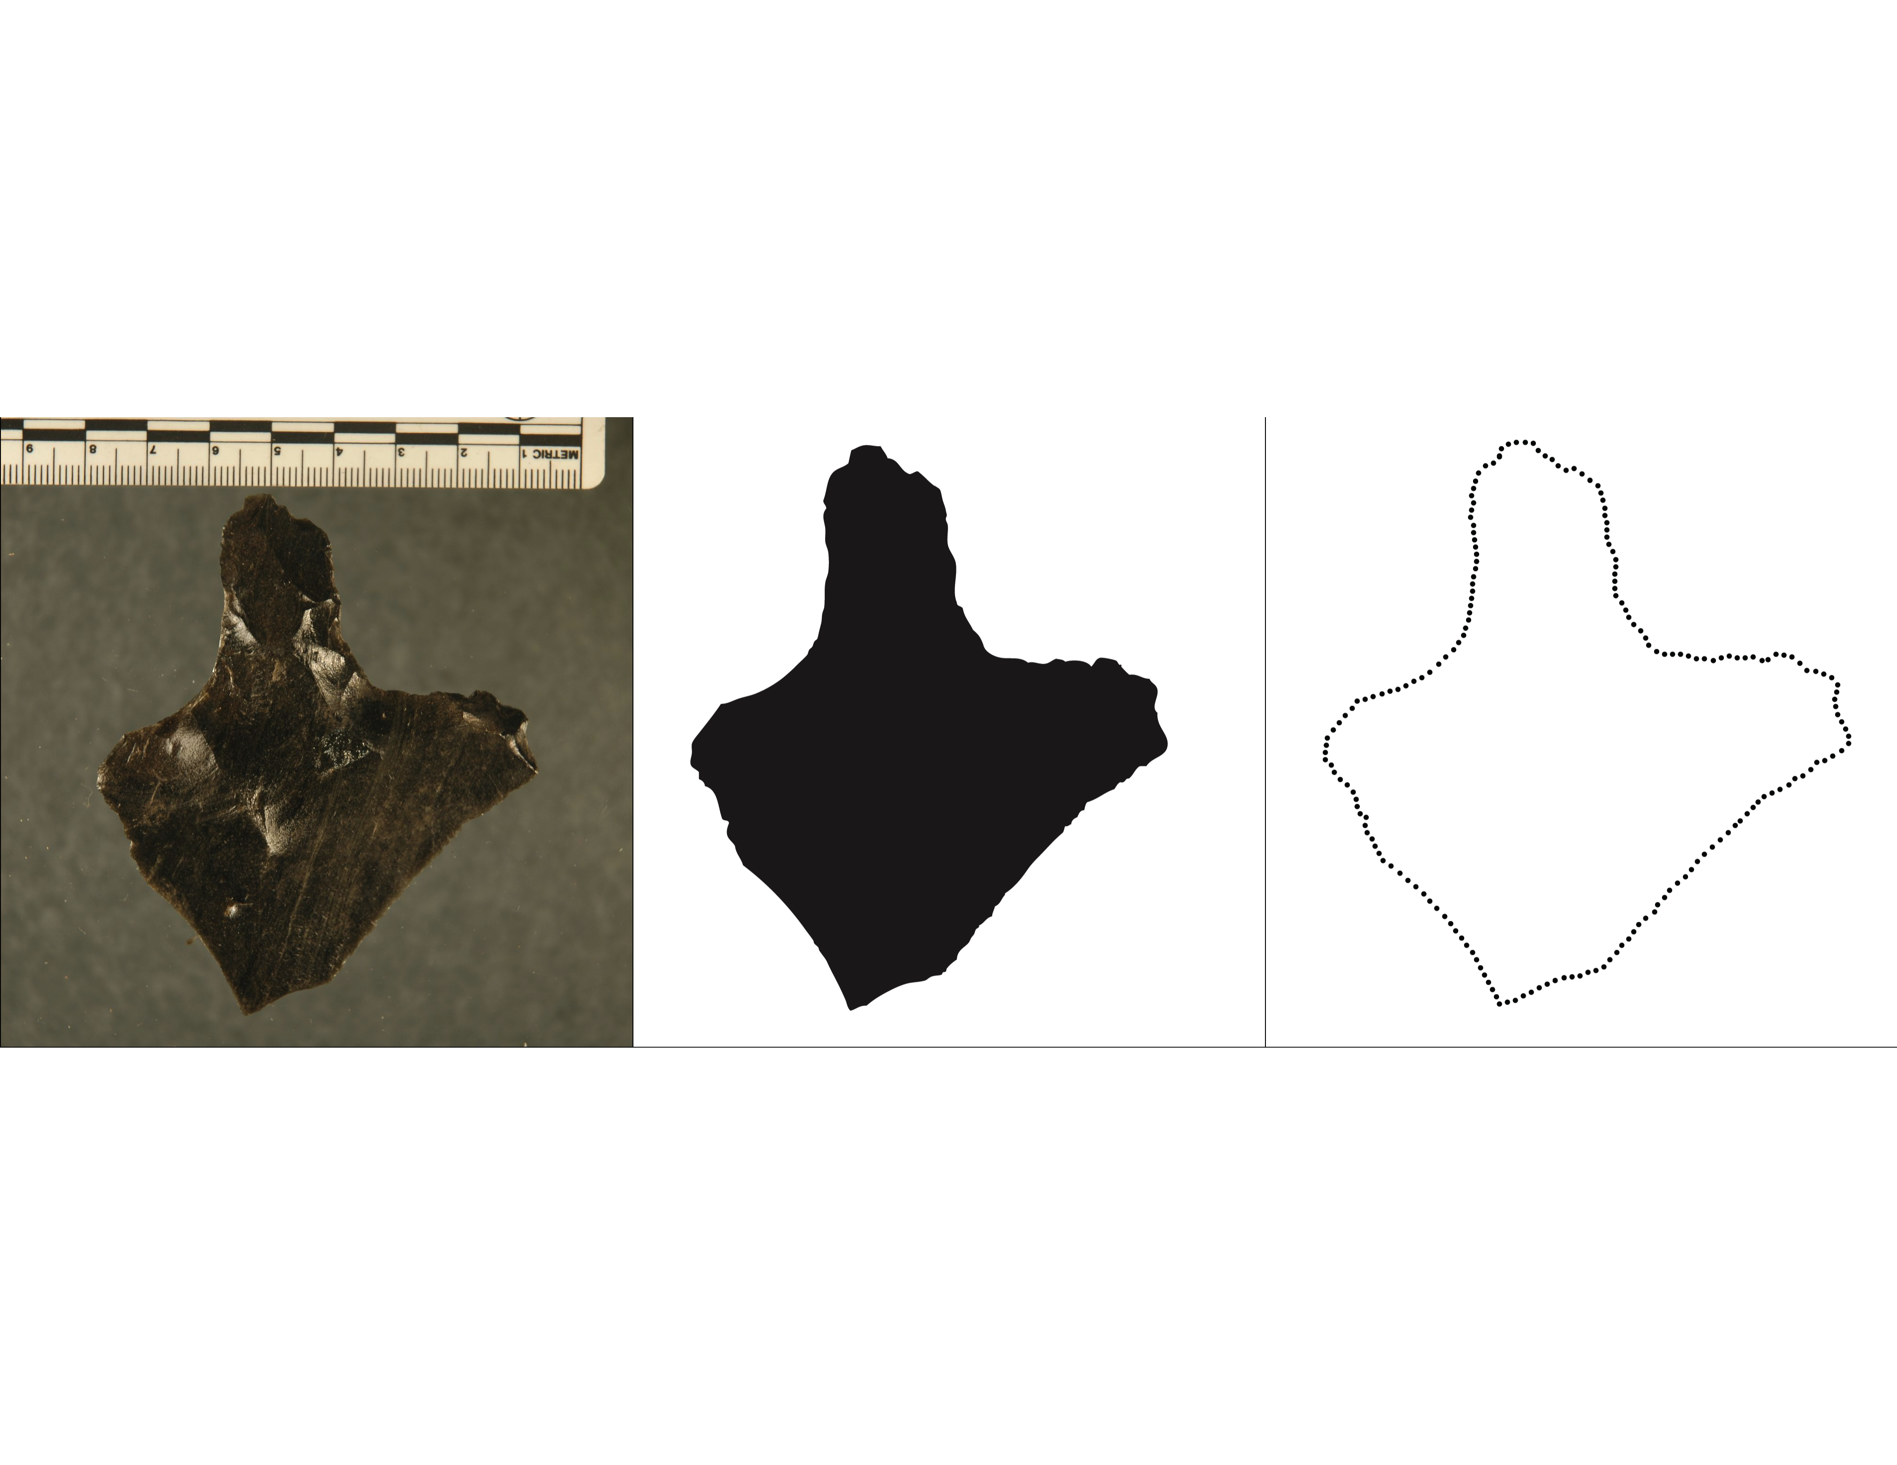

Figure 4. Measurement process used to generate semilandmark data for each *mata'a* image.

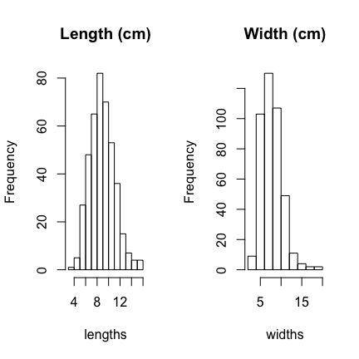

Figure 5. *Mata'a* length and width.

While the range of variability in shape shown in Figure 4 is substantial, simple metrics of length and width (Figure 5) suggest that there is just a single distribution of these objects without clear-cut modes in size. Comparisons of length and width, however, are fairly crude descriptions of shape. A more direct means of evaluating shape variability is accomplished by superimposing *mata'a* outlines (Figure 6). This process required selecting a standard reference point for all objects from which measurements would be based. We selected our reference points, referred to here as “centroids,” based on the points from which we believe variability will be meaningfully constrained (or not). In this case of *mata'a*, we chose a centroid at the center of the haft where it intersects the blade.

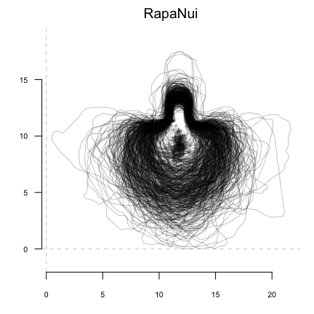

Figure 6. Superimposed *mata'a* outlines from Rapa Nui. For comparison, all *mata'a* are aligned at the center point of the haft where it meets the blade.

Once we identified the centroid, we calculated the distance from the centroids to the perimeter in one-degree intervals for the 360-degree perimeter. One-degree increments provide sufficient detail about shape at a scale that characterized overall shape variability with enough detail to capture attributes regarding the haft shape and distal blade shape outline.

While our measured outlines are composed of 200 points, Momocs interpolates between points to locate distances from centroids at even intervals.In addition, since all measurements are based on georeferenced coordinates, planimetric measure (such as width or length) can be calculated. Additional image analysis techniques to isolate object outlines point to the strong potential for automation of the measurement process, greatly increasing the ability to characterize large assemblages. With large numbers of measures of radial distances made relative to the *mata'a* centroids, we then calculate a statistical summary for each angle to assess variability in relative dimensions (Figure 7).

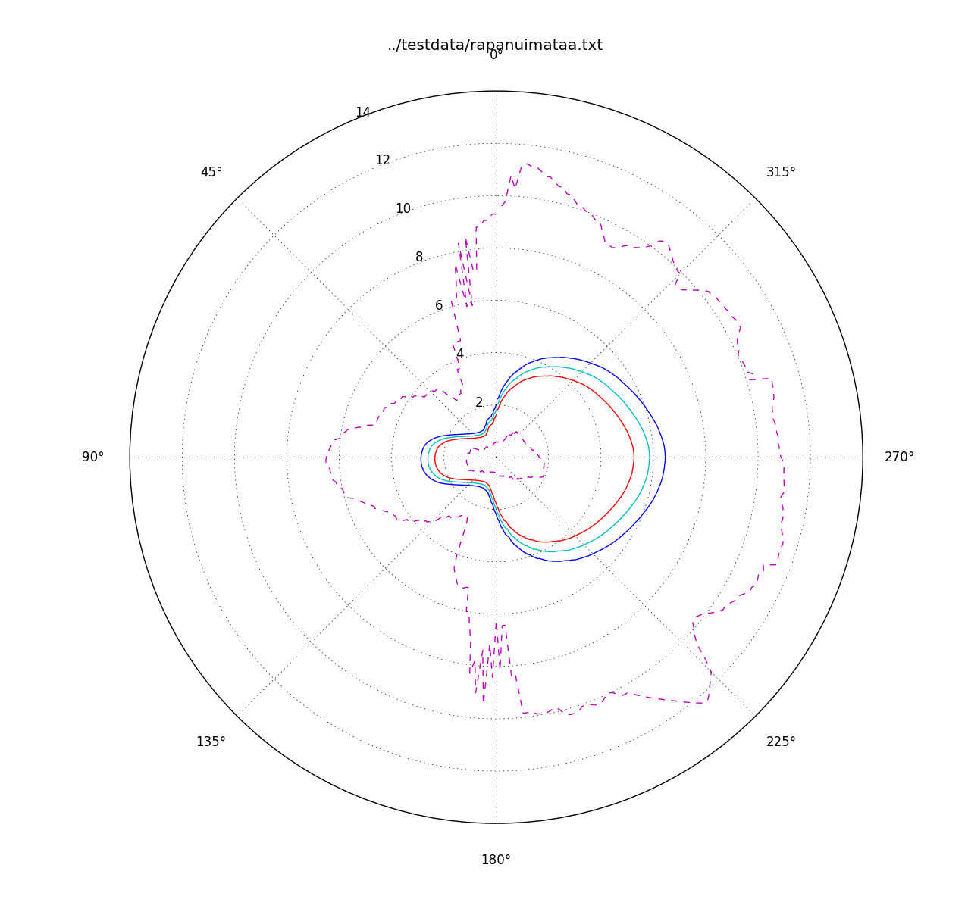

Figure 7. Variability in *mata’a* shape shown with mean and 95% confidence intervals. Note that the 95% confidence intervals are shown with exaggerated differences between the values to illustrate areas with greater variance versus those with more constrained shape. Here, the area at the base of the stem where it meets the blade is the most constrained portion of *mata'a* shape while the stem length and blade are more variable.

# Morphometric Analyses

Some text here about the various ways in which morphometrics can be done.

## Elliptic Fourier Analysis

Fourier based analyses are powerful tools for the study of shape variability (Claude 2008). Fourier approaches decompose shape into a periodic function that is the sum of simple trigonometric functions such as sine and cosine. These simple functions are frequencies that are integer multiples, i.e. are harmonics, of one another. Lower harmonics provide approximation for the coarse-scale trends in the original periodic function while the high-frequency harmonics fit its fine-scale variations (Figure 8). In morphometrics, Fourier treats closed outlines as periodic functions. If you start somewhere on the outline and follow it, you will pass again and again by the same starting point and thus periodic functions can describe this outline. These functions can uses a variety of descriptive data for the outline: the distance of any point on the outline to the centroid of the shape, the variation of the tangent angle for any point, or the (x/y) position on the plane (Rohlf & Archie 1984). For an outline shape, a periodic function is obtained and can be decomposed (and thus described) by Fourier series.

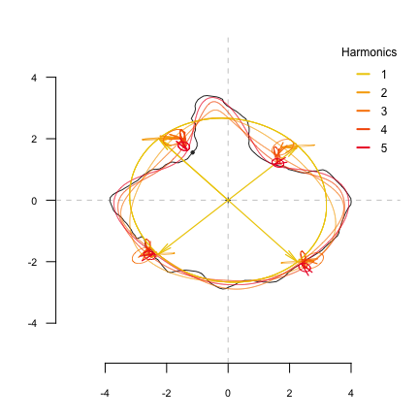

Figure 8. For all positive integers, the sum of a cosine curve and a sine curve defines an ellipse in the plane. Elliptic Fourier analysis is based on an harmonic sum of such ellipses. Five harmonics are here shown at four locations on the original outline of a *mata'a*. As the number of harmonics is increased the reconstruction better approximates the original shape outline.

Fourier series, however, work on continuous functions. Since in practice shape is measured on a finite number of discrete points on a plane (in our case, x/y coordinates), a discrete equivalent to Fourier series is used in morphometrics. A given number of points called pseudolandmarks have to be sampled along the outline before computing shape analysis. All Fourier decomposition then result in an harmonic sum of trigonometric functions associated with harmonic coeffi- cients. They are (usually) normalized to remove homothetic, translational or rotational differences between shapes. Two or four coefficients, depending on the approach used, are obtained for each calculated harmonic and can then be considered as quantitative variables. Nyquist frequency impedes us from having more harmonics than half the number of points fitted, which is thus the upper limit. The geometrical information contained in the outlines are thus quantified and can be analysed with classical multivariate tools.

# Harmonic Power

To conduct Fourier analysis, we must estimate the number of necessary harmonics after examining the spectrum of harmonic Fourier power. The power is proportional to the harmonic amplitude and can be considered as a measure of shape information. As the rank of a harmonic increases, the power decreases and adds less and less information. We can evaluate the mininum number of harmonics required to best approximate the shape. In the case of the *mata'a* and using x/y position for points on the outline as the data set, 12 harmonics provide a good reconstruction of the overall shape (Figures 9 and 10).

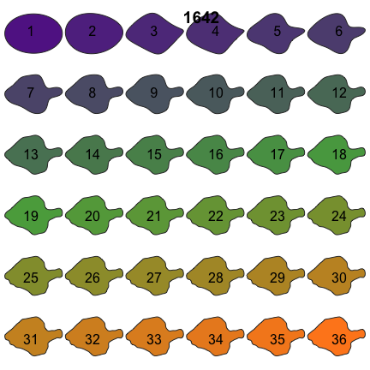

Figure 9. *Mata'a* reconstructed from different numbers of harmonics. Twelve harmonics provide a satisfactory reconstruction.

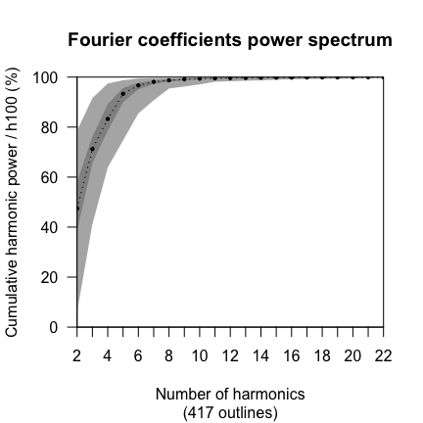

Figure 10. Cumulated harmonic Fourier power calculated from Rapa Nui *mata'a*. The 12 first harmonics gather nearly 100% of the harmonic power. Maxima, minimaRapa and medians are also plotted.

Based on the elliptical Fourier characterizations of the *mata'a* we can now examine the shapes to determine if there are clusters of shape classes that might distinguish different functional sub-groups from each other. Figure 11 presents the position of mata'a shapes on a factorial map with shapes reconstructed from first two principal compoonent axes. Based on these data we do not have discrete shape groups: *mata'a* are highly variable in outline shape and there are continuous intermediate shapes between all variants. This finding demonstrates that the similarity of the proximal haft end of the *mata'a* and that the distal end is free to vary. These results fail to indicate any subgroup that might have been specifically built as lethal weapons and supports the notion that mata'a have no particular function for which blade shape affects performance. Given observations of usewear on the blade edges (e.g., Church 1998; Church & Rigney 1994; Church & Ellis 1996; Stevenson & Cardinali 2008: 107), it is likely that this means that *mata'a* simply must have an edge sufficient for cutting and scraping.

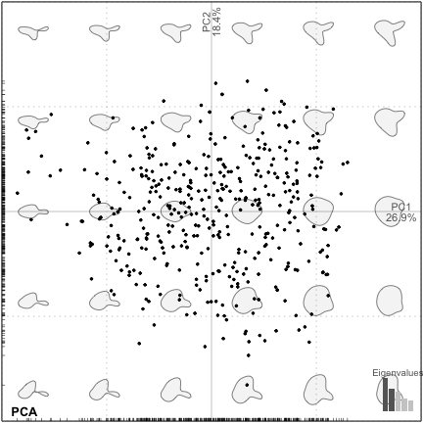

Figure 11. First two principal components (PC1 and PC2 are on the x- and y-axis, respectively) for the Rapa Nui *mata'a*.

We can also examine the *mata'a* to see if there are systematic differences between the locations from which *mata'a* are found or between the obsidian sources used to make the artifacts. In our analyses, we have examples of *mata'a* from 0 sites (Table 4).

Table 4: Rapa Nui *mata'a* included in analyses by site.

|  |  |  |  |  |  |
| --- | --- | --- | --- | --- | --- |
|  | Ahu Tautira | Orito | Orongo | Rano Kau | Unknown |
| Bishop | 0 | 0 | 0 | 0 | 291 |
| Englert | 25 | 31 | 29 | 33 | 0 |

Figure 12 presents the distribution of sets of *mata'a* from multiple locations across the island. The graph includes the confidence ellipses for the 0 sites on the grid representing the morphological space based on the first two principal components. The overlap of the groups indicates that the shapes from each of the sites are cannot be distinguished. The same conclusion can be drawn from an analysis of the shape variability relative to obsidian source (Figure 13). Overall, there appears to be no evidence that *mata'a* blade shape was constrained due to functional performance.

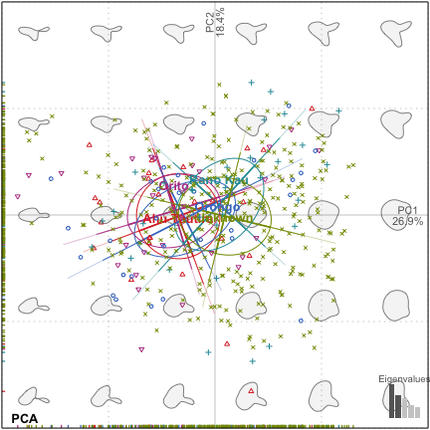

Figure 12. First two principal components of *mata'a* grouped by site location.

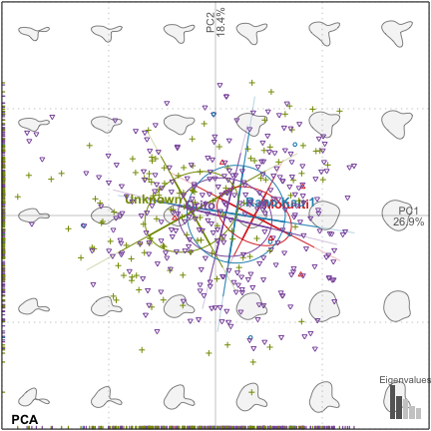

Figure 13. First two principal components of *mata'a* grouped by site location.

# Comparison with stemmed tools from other Pacific Islands

The *mata'a* of Rapa Nui share some similarity with stone tools found on other islands across the Pacific. On New Britain in Melanesia, for example, Torrence (2009, [-@Torrence](mailto:-@Torrence):2009ab; 2013) has described obsidian stemmed tools that share much in common with the shape of *mata'a.* Torrence (see also Kononenko 2012) argues that these tools may have been used for range of activities including tatooing and ritual scarification. Pitcairn Island is remote Eastern Polynesian island that is located ca. 1900 km to the west of Rapa Nui. The island was inhabited by historically related Polynesian populations, though abandoned during prehistory. Stemmed lithics of chert known as locally as "mataa" are also found on the Chatham Islands and on New Zealand (Jones 1981). An additional but limited comparison can be made with Pitcairn Island, where a few stemmed lithic tools have been found (Heyerdahl & Ferdon 1965).

As a comparison for our study, we generated outlines of examples stemmed lithic tools from published images and drawings of these islands using the same procedure for Rapa Nui. Our elliptic Fourier analyses of shape variability, required 13 harmonics to adequately characterize the shape of all of the stemmed artifacts. While the sample sizes of the non-Rapa Nui assemblages are small, when we compare the shapes of Rapa Nui *mata'a* with those other objects, we find that the Pitcairn Island stemmed artifacts have overall shapes that are quite distinct. While we cannot rule out the possibility that the Pitcairn examples are a few extremely long and pointed shapes that happen to have been collected from a much wider array of variability, these shapes are certainly more consistent with hafted tools for hunting or weapons. The New Zealand mataa are similar but have substantially thicker stems than the Rapa Nui artifacts. Jones (1981) suggests that this might reflect tools that are hafted with the edge perpindicular to the shaft like an adze. Given their chert composition and relatively steep edge angles, this shape might be well suited for wood working.

The New Britain artifacts, on the other hand, wide array of features that are more like the ones from Rapa Nui. Based on this comparison, it is certainly conceivable that one of Rapa Nui *mata'a* reflect the same kinds of uses that are thought to characterize the New Britain tools. Tatooing is known from Rapa Nui through ethnohistoric observation (Huish 1839: 77; Métraux 1940; Thomson 1891: 22) and as markings on the prehistoric *moai* (Lee 1992). It would not be surprising that at least some of the mata'a objects were used in tatooing and scarification practices, though their numbers and widespread distribution suggests that they were likely not all used in this fashion.

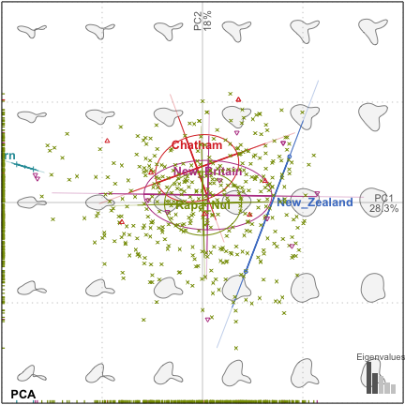

Figure 14: Factorial maps depicting the two principal compoents (PC1 and PC2 are the x- and y-axis, respectively) of morphological variation for stemmed lithic shaped objects from Rapa Nui, New Britain, New Zealand, Chatham and Pitcairn Islands. The shapes are reconstructed from the factorial map using the first two component axes.

# Conclusion

While the notion that Rapa Nui prehistory consists of a tale of collapse and self-destruction remains popular, the evidence to support this claim is non-existent. In addition to lack of defensive structures and skeletal evidence of lethal violence (Hunt & Lipo 2011a), the so-called "weapons of mass destruction" (Keegan 1993) take a careful look at the shape of *mata'a* we simply do not see evidence that these class of artifacts represent lethal weapons (see also Ingersoll & Ingersoll 2013). There appears to be no performance requirements that would influence the blade shape. Other than having an edges, mata'a are no more lethal than throwing any other kind of rock. Indeed, as documented in post-contact Rapa Nui, rock throwing from high points is the primary way in which native Rapanui fought off the instrusion of Europeans, (e.g., Roggeveen's 1722 visit, Eyzaguirre 2004).

That *mata'a* had more than one function is not surprising since it is essential to resist the notion that any object is imbibed with an inherent function (Dunnell 1978). Instead, we measure function on the empirical variability for any assemblage of objects (Dunnell *et al.* 1976). In the case of *mata'a* the wear patterns and distribution in rock mulch suggest that at least some of these objects were employed in cultivation. We also cannot rule out that they were used in tattooing and scarification practices. The latter function certainly is consistent with observations of healed scars made by Spanish visitors in AD 1770 (Corney *et al.* 1908).

It is unfortunate that in the case of Rapa Nui, the myth of the island continues to persist despite the lack of evidence. Tradition has long trumped empirical inquiry when it comes to the understanding the functional role that *mata'a* played within the subsistence and social dimensions of prehistoric Rapa Nui. In the case of Rapa Nui, getting the correct answer is far from a trivial academic exercise. The island's prehistory is often used as an exemplar of ignoring the impacts humans made on the environment and thus is driving policy decisions. United Kingdom Prime Minister Margaret Thatcher, for example, famously used Rapa Nui as a warning in a 1989 presentation to the General Assembly of United Nations (e.g., Thatcher 2014). Similarly, *Mata'a* have been used as examples of mass effect "weapons" in a study of terrorist tactics (Rasmussen & Hafez 2010). Given the contemporary importance that Rapa Nui has in guiding our concerns for our future, we owe it to ourselves to make certain that we fully understand the prehistory of the island and that our understanding is based on well documented evidence.

# References Cited

Araho, N. 1997. *Obsidian stemmed tools from west new britain, papua new guinea*. University of Sydney.

Bahn, P. & J. Flenley. 1992. *Easter island, earth island*. London: Thames; Hudson.

Balfour, H. 1917. Some ethnological suggestions in regard to easter island, or rapanui *Folklore* 28: 356–81.

Bollt, R., J.E. Clark., P.R. Fisher. & H.K. Yoshida. 2006. An experiment in the replication and classification of easter island mata’a *Rapa Nui Journal* 20: 125–33.

Bonhomme, V. 2012. A graphical introduction to momocs and outline analysis using r. <http://www.vincentbonhomme.fr/Momocs/vignettes/>.

Bonhomme, V., S. Picq., C. Gaucherel. & J. Claude. 2014. Momocs: Outline analysis using r *Journal of Statistical Software* 56: 1–24.

Bookstein, F.L. 1982. Foundations of morphometrics *Annual Review of Ecology and Systematics*, 451–70. [http://www.filogenetica.org/cursos/deluna/morfometria/referencias en pdf/Bookstein82.pdf](http://www.filogenetica.org/cursos/deluna/morfometria/referencias%20en%20pdf/Bookstein82.pdf).

— 1991. *Morphometrics tools for landmarks data*. Cambridge University Press.

— 1997. Landmark methods for forms without landmarks: Morphometrics of group differences in outline shape *Medical Image Analysis* 1: 225–43. <http://femininebeauty.info/i/bookstein.sliding.pdf>.

Bookstein, F.L., B. Chernoff., R.L. Elder., J. Humphries., G.R. Smith. & R.E. Strauss. 1985. *Morphometrics in evolutionary biology: The geometry of size and shape change, with examples from fishes*. Academy of Natural Sciences of Philadelphia Philadelphia.

Bork, H.-R., A. Mieth. & B. Tschochner. 2004. Nothing but stones? A review of the extent and technical efforts of prehistoric stone mulching on rapa nui *Rapa Nui Journal* 18: 10–14.

Bowman, A. 2009. Review of ’morphometrics with r’ *Journal of Statistical Software* 31: 1–2.

Cardillo, M. 2010. Some applications of geometric morphometricsto archaeology, in A. Elewa (ed.) *Morphometrics for nonmorphometricians*: 325–41. Springer-Verlag.

Church, F. 1998. Upland, lowland, citizen, chief: Patterns of use-wear from five easter island sites., in G.L. Christopher M. Stevenson & F.J. Morin (ed.) *Easter island in pacific context south seas symposium: Proceedings of the fourth international conference on easter island and east polynesia*: 312–15. Easter Island Foundation, Los Osos.

Church, F. & G. Ellis. 1996. A use-wear analysis of obsidian tools from an ana kionga *Rapa Nui Journal* 10: 81–88.

Church, F. & J. Rigney. 1994. A microwear analysis of tools from site 10-241, easter island–An inland processing site *Rapa Nui Journal* 8: 101–5.

Claude, J. 2008. *Morphometrics with r*. Springer.

Corney, B.G., F. González de Haedo. & J. Roggeveen. 1908. *The voyage of captain don felipe gonzález in the ship of the line san lorenzo, with the frigate santa rosalia in company, to easter island in 1770-1. preceded by an extract from mynheer jacob roggeveen’s official log of his discovery of and visit to easter island in 1722*. Book. Works Issued by the Hakluyt Society, 2d Ser., No. 13. Cambridge: Printed for the Hakluyt Society, Cambridge.

Diamond, J. 1995. Easter’s end *Discover* 9: 62–69.

— 2005. *Collapse: How societies choose to fail or succeed*. Viking, New York.

Dunnell, R.C. 1978. Style and function: A fundamental dichotomy *American Antiquity* 43: 192–202.

— 1986. Methodological issues in americanist artifact classification *Advances in Archaeological Method and Theory* 9: 149–207.

Dunnell, R.C., D.E. Lewarch. & S.K. Campbell. 1976. *Test excavations at the hamilton island site, 45-sA-12*. Journal Article. Dept. of Anthropology, University of Washington.

Edwards, E., R. Marchetti., L. Dominichetti. & O. Gonzales-Ferran. 1996. When the earth trembled, the statues fell *Rapa Nui Journal* 10: 1–15.

Eyzaguirre, E.R.-T. (ed.) 2004. *Easter island: The first three expeditions*. Rapanui Press.

Flenley, J. & P.G. Bahn. 2003. *The enigmas of easter island: Island on the edge*. Oxford ; New York: Oxford University Press, New York.

Gunz, P. & P. Mitteroecker. 2013. Semilandmarks: A method for quantifying curves and surfaces *Hystrix, the Italian Journal of Mammalogy* 24: 103–9. <http://www.italian-journal-of-mammalogy.it/article/download/6292/pdf_6292>.

Haedo, F.G. de. & J. Roggeveen. 1908. *The voyage of captain don felipe gonzález: In the ship of the line san lorenzo, with the frigate santa rosalia in company, to easter island in 1770-1*. Vol. (13). 13. Hakluyt society.

Hammer, Ø., Harper D.A.T. & P. D. Ryan. 2001. PAST: Paleontological statistics software package for education and data analysis *Palaeontologia Electronica* 4: 1–9.

Heyerdahl, T. 1989. *Easter island–the mystery solved*. London: Souvenir Press, Longdon.

Heyerdahl, T. & E. Ferdon. 1965. *Reports of the norwegian archaeological expedition to easter island and the east pacific*. Vol. 2. London: Allen; Unwin.

Huish, R. 1839. *A narrative of the voyages and travels of captain beechey, to the pacific and behring’s straits; performed in the years 1825, 26, 27 and 28. for the purpose of co-operating with the expeditions under captains parry and franklin. and of captain back, r.N., to the thlew-ee-choh river & the arctic sea, in search of the expedition under capt. j. ross, r.N., being the conclusion of the series of voyages instituted for the discovery of the north west passage*. W. Wright, Southwark.

Hunt, T.L. 2007. Rethinking easter island’s ecological catastrophe *Journal of Archaeological Science* 34: 485–502.

Hunt, T.L. & C.P. Lipo. 2006. Late colonization of easter island *Science* 311: 1603–6. [<Go to ISI>://000236029500044](%3cGo%20to%20ISI%3e://000236029500044).

Hunt, T.L. & C.P. Lipo. 2007. Chronology, deforestation, and ‘collapse:’ evidence vs. faith in rapa nui prehistory *Rapa Nui Journal* 21: 85–97.

— 2009a. Revisiting rapa nui (easter island) ‘ecocide’ *Pacific Science* 63: 601–16.

— 2009b. Ecological catastrophe, collapse, and the myth of `ecocide’on rapa nui (easter island), in P.A. McAnany & N. Yoffee (ed.) *Questioning collapse: Human resilience, ecological vulnerability, and the aftermath of empire*: 21–44. New York: Cambridge University Press.

— 2011a. Easter island’s complex history *Nature* 479: 41.

Hunt, T.L. & C.P. Lipo. 2011b. *The statues that walked*. Simon; Schuster, New York.

Ingersoll, D.W. & K.B. Ingersoll. 2013. Art of distraction: Rocking the farm, in B.D. Lundy (ed.) *The art of anthropology / the anthropology of art*: 23–64. 42. Newfound Press, Knoxville.

Jones, K. 1981. New zealand mataa from marlborough, nelson and the chatham islands *New Zealand Journal of Archaeology* 3: 89–107.

Keegan, J. 1993. *A history of warfare*. Vintage Books, New York.

Kendall, D. 1989. A survey of the statistical theory of shape. *Statistical Science* 4: 8–120.

Kononenko, N. 2012. Middle and late holocene skin-working tools in melanesia: Tattooing and scarification? *Archaeology in Oceania* 47: 14–28.

Ladefoged, T., C. Stevenson., P. Vitousek. & O. Chadwick. 2005. Soil nutrient depletion and the collapse of rapa nui society *Rapa Nui Journal* 19: 100–105.

Ladefoged, T.N., A. Flaws. & C.M. Stevenson. 2013. The distribution of rock gardens on rapa nui (easter island) as determined from satellite imagery *Journal of Archaeological Science* 40: 1203–12. <http://ac.els-cdn.com/S0305440312004049/1-s2.0-S0305440312004049-main.pdf?_tid=f191146e-3120-11e3-a2fe-00000aab0f27&acdnat=1381350511_fcbdd8c0c5fa27f7cfbeca2d9d9b645e>.

Ladefoged, T.N., C.M. Stevenson., S. Haoa., M. Mulrooney., C. Puleston., P.M. Vitousek. & O.A. Chadwick. 2010. Soil nutrient analysis of rapa nui gardening *Archaeology in Oceania* 45: 80–85. <http://oceania.metapress.com/index/TQ0202781J021860.pdf>.

Lee, G. 1992. *Rock art of easter island: Symbols of power, prayers to the gods*. Institute of Archaeology, University of California, Los Angeles.

Lipo, C.P. & T.L. Hunt. 2009. AD 1680 and rapa nui prehistory *Asian Perspectives* 48: 309–17.

Lipo, C.P. & T.L. Hunt. 2014. Easter island, archaeological evidence, and the evolutionary history of warfare *The 79th annual society for american archaeology meeting*. Austin, TX: Society for American Archaeology.

Lipo, C.P., T.D. Hunt. & R.C. Dunnell. 2012. Formal analyses and functional accounts of groundstone ‘plummets’ from poverty point, louisiana *Journal of Archaeological Science* 39: 84–91. <http://www.sciencedirect.com/science/article/pii/S0305440311003220>.

Lipo, C.P., T.L. Hunt. & S.R. Haoa. 2013. The ’walking’ megalithic statues (moai) of easter island *Journal of Archaeological Science* 40: 2859–66. <http://ac.els-cdn.com/S0305440312004311/1-s2.0-S0305440312004311-main.pdf?_tid=f622ffde-26d9-11e3-8676-00000aab0f6b&acdnat=1380220513_ddb22278741acb37f8d0b21c65e7d41a>.

Lipo, C.P., T.L. Hunt. & B. Hundtoft. 2010. Stylistic variability of stemmed obsidian tools (mata’a), frequency seriation, and the scale of social interaction on rapa nui (easter island) *Journal of Archaeological Science* 37: 2551–61. <http://www.sciencedirect.com/science/article/pii/S0305440310001779>.

Metraux, A. 1957. *Easter island: A stone-age civilization of the pacific*. Oxford University Press.

Métraux, A. 1940. *Ethnology of easter island*. Honolulu: Bishop Museum Press, Honolulu.

Mieth, A., H. Bork., J. McNeill. & V. Winiwarter. 2006. *The dynamics of soil, landscape and culture on easter island (chile).* White Horse Press. <http://www.cabdirect.org/abstracts/20103285130.html>.

Morrison, A. 2012. An archaeological analysis of rapa nui settlement structure: A multi-scalar approach. PhD thesis, Department of Anthropology, University of Hawai’i, Manoa.

Mulloy, W. 1961. Ceremonial center of vinapu, in T. Heyerdahl & E. Ferdon (ed.) *The archaeology of easter island*: 93–180. 24. Monograph of the School for American Research; the Kon Tiki Museum.

Mulrooney, M. 2012. Continuity or collapse? Diachronic settlement and land use in hanga ho`onu, rapa nui (easter island). PhD thesis, Department of Anthropology, University of Auckland.

Mulrooney, M., T.N. Ladefoged., C.M. Stevenson. & S. Haoa. 2009. The myth of aD 1680: New evidence from hanga ho’Onu, rapa nui (easter island) *Rapa Nui Journal* 23: 94–105.

Mulrooney, M.A., A. McAlister., C.M. Stevenson., A.E. Morrison. & L. Gendreau. 2014. Sourcing rapa nui mata`a from the collections of bishop museum using non-destructive pXRF *Journal of the Polynesian Society* In Press.

Rainbird, P. 2002. A message for our future? The rapa nui (easter island) ecodisaster and pacific island environments *World Archaeology* 33: 436–51. <http://links.jstor.org/sici?sici=0043-8243(200202)33%3A3%3C436%3AAMFOFT%3E2.0.CO%3B2-W>.

Rasmussen, M.J. & M.M. Hafez. 2010. Terrorist innovations in weapons of mass effect: Preconditions, causes and predictive indicators. Workshop Report. The Defense Thread Reduction Agency, Advanced Systems; Concepts Office.

Rohlf, F. & J. Archie. 1984. A comparison of fourier methods for the description of wing shape in mosquitoes (diptera: Culicidae). *Systematic Biology*, 302–17.

Rohlf, F.J. 1990. Morphometrics. *Annual Review of Ecology and Systematics* 21: 299–316.

— 2014. TPS software. <http://life.bio.sunysb.edu/ee/rohlf/software.html>.

Routledge, K. 1919. *The mystery of easter island: The story of an expedition*. Sifton, Praed, London.

Saher, H. von. 1990. Some details from the journal of captain bouman on the discovery of easter island *Rapa Nui Journal* 6: 34–39.

Skinner, H.D. 1958. Some recent publications relating to easter island culture and its probable history *The Journal of the Polynesian Society* 67: 248–51.

Specht, J., R. Fullagar., R. Torrence. & N. Baker. 1988. Prehistoric obsidian exchange on melanesia: A perspective from the talasea sources *Australian Archaeology*, 3–16. <http://www.jstor.org/stable/40286657>.

Stevenson, C.M. & S.H. Cardinali. 2008. *Prehistoric rapa nui: Landscape and settlement archaeology at hanga ho’onu.* Easter Island Foundation, Los Osos.

Stevenson, C.M., T.L. Jackson., A. Mieth., H.-R. Bork. & T.N. Ladefoged. 2006. Prehistoric and early historic agriculture at maunga orito, easter island (rapa nui), chile *Antiquity* 80: 919–36.

Stevenson, T.L., C. M. & S. Haoa. 2002. Agricultural production in an uncertain environment *Rapa Nui Journal* 16.

Thatcher, M. 2014. Speech by margaret thatcher to united nations general assembly (global environment) 11/8/1989. <http://www.unep.org/Documents.Multilingual/Default.asp?DocumentID=2712&ArticleID=9462&l=en>.

Thompson, D.W. 1917. *On growth and form*. Cambridge University Press.

Thomson, W.J. 1891. *Te pito te henua; or, easter island*. Government Printing Office: Washington.

Torrence, R., S. Kelloway. & P. White. 2013. Stemmed tools, social interaction, and voyaging in early–mid holocene papua new guinea *The Journal of Island and Coastal Archaeology* 8: 278–310. <http://www.tandfonline.com/doi/abs/10.1080/15564894.2012.761300>.

Torrence, R., P. Swadling., W. Ambrose., N. Kononenko., P. Rath. & M. Glascock. 2009. Obsidian stemmed tools and mid-holocene interaction *Asian Perspectives* 48: 118–47.

Torrence, R., P. Swadling., N. Kononenko., W. Ambrose., P. Rath. & M.D. Glascock. 2009. Mid-holocene social interaction in melanesia: New evidence from hammer-dressed obsidian stemmed tools *Asian Perspectives* 48: 119–48. <http://scholarspace.manoa.hawaii.edu/bitstream/handle/10125/29084/AP_V48No1_torrence.pdf?sequence=1>.

Wilmshurst, J.M., T.L. Hunt., C.P. Lipo. & A. Anderson. 2011. High-precision radiocarbon dating shows recent and rapid initial human colonization of east polynesia *Proceedings of the National Academy of Science* 108: 1815–20.